# *Lab 6 – Use Case Analysis and Activity Diagrams*

Date assigned: Monday, February 13, 2017

Date due: **Wednesday, February 15, 2016, 14:50**

**Learning Objectives**

Upon successful completion of this lab exercise, the student will be able to:

* Demonstrate the analysis of Use Cases to form an object/sub-system list
* Design activity diagrams
* Practice the creation of Activity Diagrams in LucidCharts

Lab Set Up

1. Create a copy of this document called YourUsername_E21_L06.docx for E21 on your home drive.
2. **All diagrams are to be done in LucidCharts**

To do:

# Part A – Activity Diagram with LucidCharts

1. Using the Bank ATM withdrawal use case discussed in class (S07 Use Case Analysis). Draw an Activity Diagram to capture this use case (paste below). This is just a simple diagram without any/many branches to get you used to the syntax and the tool. Be sure to use the UML template/tools in LucidChart.

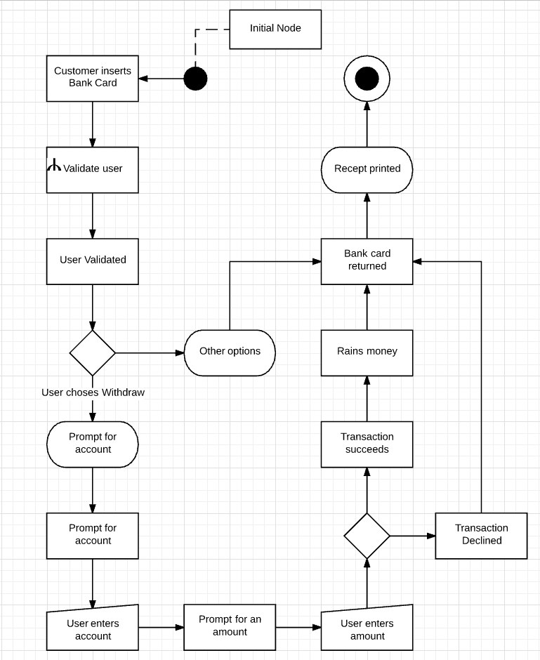

DO IT IN UML, NOT FLOWCHART GUARD CONDITIONS

# Part B – Parking Lot Booking Service – Use Case

1. Draw a Use Case Diagram of the Parking Lot Booking service. Show generalization for teachers vs students (i.e. things users in general can do).

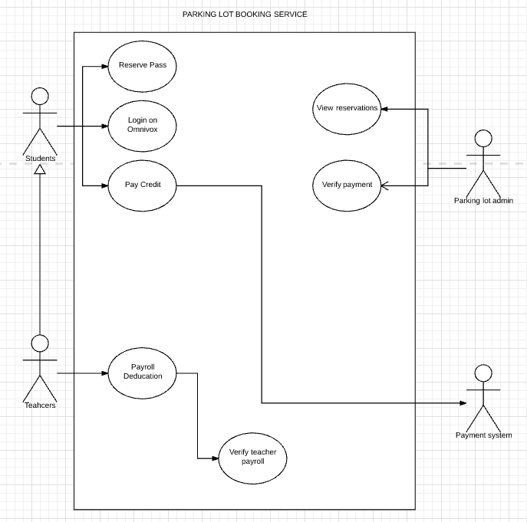

# Part C – Parking Lot Booking Service – Analysis and Activity Diagram

*Analysis and Activity Diagram. You will be using the Parking Lot Booking service of Lab 4. This is partially a design effort as the system isn’t fully defined for you in advance, but you are attempting to describe the system you are envisioning.*

1. Define the steps required for the use case of purchasing a parking pass.

CASH FLOW

INTERACTIONS WITH ADMIN

* Log into omnivox
* Select buy parking pass
* Enter banking information
* Get parking pass

1. Provide an activity diagram for the use case of purchasing a parking pass.

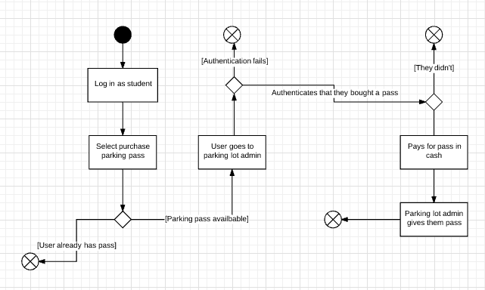

EVERY GUARD CONDITION SHOULD HAVE AN ACTION

1. Add swimlanes to your Activity Diagram. Show more detail with subsystem/actors in columns. (Paste below). Suggested swimlanes are Student/Teacher, Parking Lot Booking Service, Omnivox, Payment system, Administrator

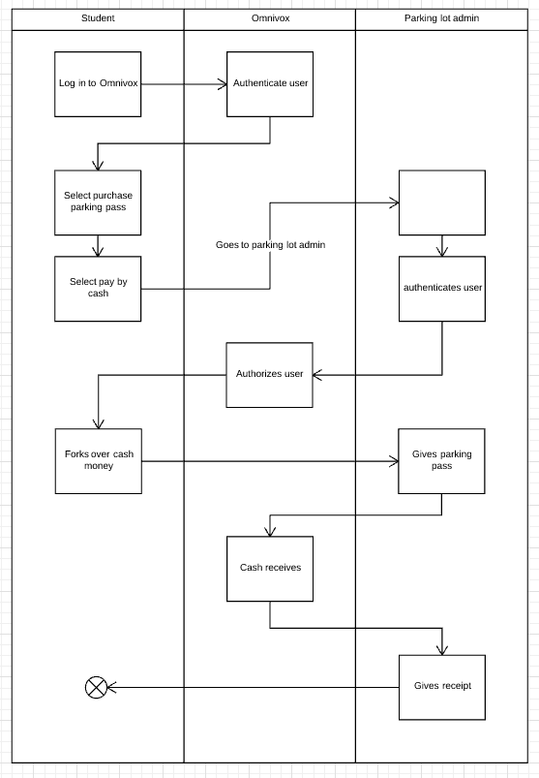

SWIM LANES INCLUDE ERROR PATHS

1. Provide a list of **candidate** classes/sub-systems for the **whole** Parking Lot Booking use case. Create table below.

Candidate Classes:

|  |  |
| --- | --- |
| Candidate class | Sub-class |
| Student | Omnivox log-in |
| Parking lot admin | Payroll system |
| Omnivox | Payment system |
| Teacher | Payment system |
| Credit card system |  |

ALL NOUNS ARE CANDIDATES FOR CLASSES

1. Provide an analysis of each candidate and a final class list using the same formats shown in class.

Student must be a class because user needs to log in as something

Parking lot admin must be a class because they contain a set list of attributes and a role

Teacher must be a class, same as student

Omnivox can be a class, but really it’s the system as a whole. The students and teacher classes are part of the omnivox system. The payroll and payment systems are all part of the omnivox system. It’s not really a class on its own, but it’s in there.

Credit card system should be a class because there needs to be a way to access the outside systems credit card class provides a way to access the credit card system’s data.

USE FORMAT FROM S07-14

USE ALGORITH FROM S07-13

# Part D - Self Assessment

1. What did you learn in completing this lab?

To read

1. What did you have difficulty with?

Reading

1. What did you do well?

Not reading

1. How many hours did you spend in completing this lab?

4 hours working, 5 minutes reading (not really)

1. What took you the most time?

Re-doing things (because I didn’t read)

Mark breakdown

|  |  |
| --- | --- |
| **Part A** |  |
| Basic steps captured | 5 |
| UML proper syntax | 5 |
| **Part B** |  |
| 1. Use case diagram with generalization | 10 |
| **Part C** |  |
| 1. Use case diagram with generalization | 10 |
| 1. List of steps/activities | 10 |
| 1. Activity diagram | 10 |
| 1. With Swimlanes | 10 |
| 1. Candidate classes | 10 |
| 1. Class list (and analysis) | 10 |
| **Part D** |  |
| Self assessment and properly handed in, English | 5 |

To Submit

Upload the document in Word format to the Moodle page for this course.